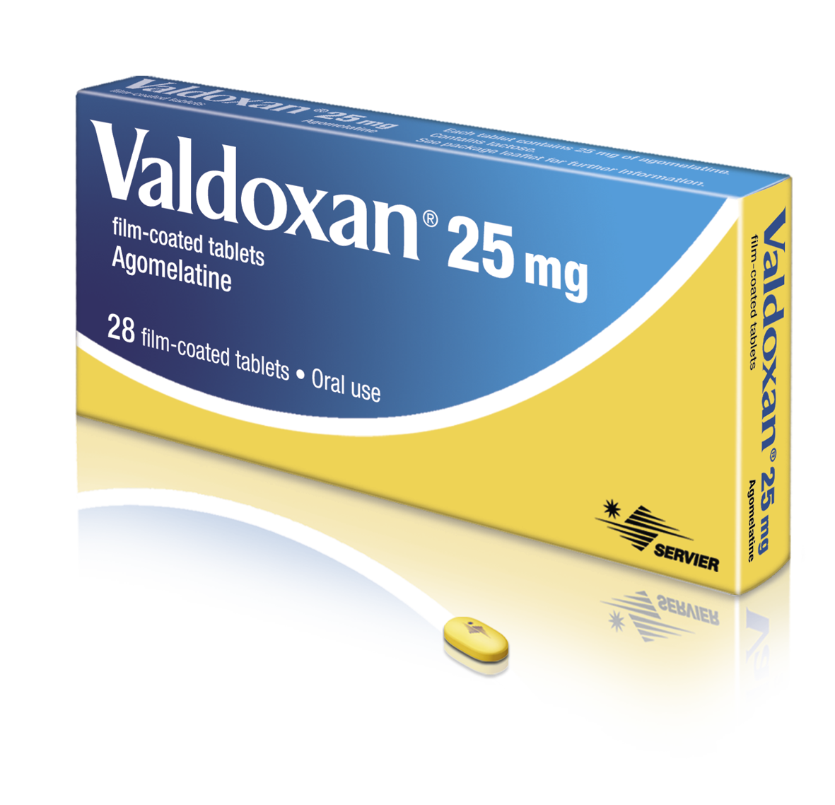
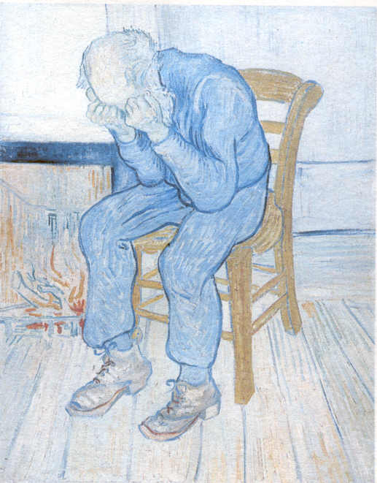
Hot Topics in Depression
18 June 2016
TAIPEI
Shangri-La’s Far Eastern Plaza Hotel

Saturday 18th June

Symposium
Valdoxan’s antidepressant efficacy :
a distinct profile for a better chance to achieve remission
Chairman: P. Gorwood
Co-chairman:Te-Jen Lai

14.00-14.10 Opening remarks
Prof Te-Jen Lai, Taiwan

14.10-14.50 A comprehensive overview of the effectiveness of Valdoxan in depressed patients through both clinical trials and clinical practice
Prof P. Gorwood, France

14.50-15.30 From improvement of interest and pleasure to recovery of functioning: the optimal way to reach remission
Prof K. Demyttenaere, Belgium

15.30-16.00 Coffee/Tea break

16.00-16.40 The efficacy of Valdoxan in elderly patients with recurrent
major depressive disorder
Dr C. Munoz, France

16.40-17.00 Panel discussion
Moderator: Prof G. Gorwood, France

17.00 Closing remarks
Prof G. Gorwood, France

